**Availability zones in Azure Kubernetes Service (AKS) overview**

An AKS cluster distributes resources, such as nodes and storage. Using availability zones.

**What are availability zones?**

Availability zones help to protect your applications and data from datacenter failures.

* **\*\*Availability Zones for High Availability**:** Each Availability Zone within a selected region physically isolated from other zones. Meaning they are in separate cooling, power and networking. This provides a Hight availability and fault tolerance for any Application.
* **\*\*Azure Design**:** Azure is designed to distribute resources across multiple Availability zones within selected regions.
* **\*\*Data center Numbers Vary:\*\*** The number of data centers within each zone can variously depending on several factors.

Instead of focusing on the exact number of data centers, just focus on the ** benefits of availability zones**.

* **\*\*Fault tolerance**:** you can still access your application even if one zone is unavailable within the selected region. Cuz the rest of the zones remain available.
* **\*\*Disaster Recovery:\*\*** you can replicate your entire applications across zones within a selected region. for DR as well.

**\*\*EX**:** a cluster in the *East US 2* region can create nodes in all three availability zones in *East US 2.* This distribution of AKS cluster resources improves cluster availability with Hight availability, low latency and resilience.

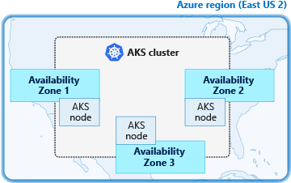

If any zone becomes unavailable, even your cluster is still available with running application and data in other zones in selected region.

**What are Azure availability zones?**

Many Azure regions provide availability zones, which are separated groups of datacenters within a region.

* Availability zones are located close enough to each other to maintain low-latency connections. They’re connected to a high-performance network with low-latency connections of less than 2ms.

The following diagram shows several example Azure regions. Regions 1 and 2 support availability zones.

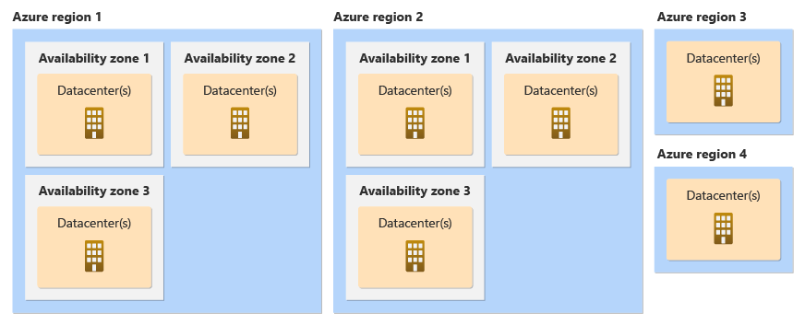

There are two ways that Azure services use availability zones:

* **Zonal** resources are associated to a specific availability zone. To ensure high reliability, you must (manage) deploy resources across multiple zones, but you must manage data replication, distribute requests, and handle failover if one zone goes down.
* **Zone-redundant** resources are spread across multiple availability zones. Microsoft manages spreading requests across zones and the replication of data across zones. If an outage occurs in a single availability zone, Microsoft manages failover automatically.

Zonal is a platform as a service (Paas)

Zonal-redundant is an infrastructure as a service (Iaas).

Note

When using availability zones with the cluster Autoscaler, it's best to create a separate node pool for each zone.

This is the meaning of create a dedicated node pool for each zone within selected region.

To keep nodes balanced distribution across zones during scale up, you can enable the **`--balance-similar-node-groups`** parameter to **true**. Without this, scaling down can lead to an unequal distribution of nodes across zones, which can affect performance. However, even with this setting, it doesn't guarantee that node groups will always have the exact same number of nodes.

* Currently, the cluster Autoscaler balancing nodes only during scale-up operations. When scaling down, the cluster Autoscaler removes underutilized nodes without considering the size of each node group.
* It adds only the number of nodes needed to accommodate all existing pods, so some groups may end up with more nodes if they have more pods scheduled.
* Additionally, the Autoscaler balances only between node groups that can run the same set of pending pods.

**Limitations**

* You are only able to configure the Availability Zones during creation of AKS cluster or node pool.
* It is not possible to update an existing non-availability zone cluster to use availability zone after creating the cluster.
* The chosen node size (VM SKU) selected must be available across all availability zones selected.
* When you configure the Availability zones enabled require using Azure Load Balancer for distribution across zones. You can only define the LB type at cluster creation time.

Azure Disk availability zones support

Volume = Storage resource

Volume can be attached to a pod. It allows the pod to store data persistently or temporarily, depending on the type of volume and its configuration.

# Azure Managed LRS (Locally Redundant Storage) Disks:

* **LRS disks** store three copies of your data, but all copies are kept within a single data center (or zone). This offers protection against hardware failure within that zone but **does not provide zone-level redundancy**.
* **Limitation in Availability Zones:** Since LRS disks are tied to a specific zone, they can only be attached to nodes within that same zone. In a multi-zone AKS cluster, if any pod is scheduled on a node in a different zone, the volume can’t be attached to that pod because the node is not available in other zones.
* **Use case:** Its only useful when don’t require cross-zone failover, where High availability isn’t mandatory.

# Azure Managed ZRS (Zone-Redundant Storage) Disks:

* **ZRS disks** store copies of your data across multiple availability zones within a region, making them **zone redundant**. This means that even if one zone goes down, your data remains accessible because it’s replicated across other zones.
* **Flexibility in Availability Zones:** ZRS disks can be attached to nodes in any zone within the same region. This is beneficial for workloads running in a **multi-zone AKS cluster**, as you don’t have to worry about assigning the pod and its volume in the same zone.
* **Z**RS ensures that the storage remains available no matter which zone the pod is scheduled in.
* **Use case:** ZRS is ideal for workloads requiring high availability across multiple zones, as it provides data redundancy and resilience to zone-level outages.

# Example of a Storage Class Using StandardSSD_ZRS Disk:

When using ZRS disks in Kubernetes, you need to define a storage class that allows the use of these zone-redundant disks.

• **skuName: StandardSSD_ZRS** specifies that the storage class should use zone-redundant Standard SSD disks.

• **volumeBindingMode: WaitForFirstConsumer** ensures that the volume is provisioned in the same zone as the pod that will consume it, which is crucial for non-redundant disks but not as critical for ZRS, since it's accessible across zones.

| **Feature** | **LRS Disks** | **ZRS Disks** |
| --- | --- | --- |
| **Data Replication** | 3 copies in a single zone | Copies distributed across multiple zones |
| **Availability Across Zones** | Not available across zones | Available across zones |
| **Use Case** | Single-zone availability | Multi-zone availability and resilience |
| **Pod Scheduling** | Must assign with thedisk in the same zone | Can be scheduled on any zone's node |